B.Sc Computer Games Development, Year 3

Game Design Document

06- Oct-2021

**“SHHHHHH...!”**

Authors: Masih Shafieian , Eoin Galavan , Adrien Dudon

Project Supervisor: Peter Lowe

# 

Table of contents

Overview

The Elevator Pitch / High Concept

Theme, Setting and Genre

Player Experience Goals

View

Targeted platform(s)

Technical requirements(s)

GamePlay

The First Minute (60 seconds of play)

Game progression

Level progression

Objectives/Victory Conditions

Features

Game World

Game geography

Game World Elements; Pieces/Enemies/Characters/Items/Spells [Game dependant]

Levels

Level description

Interface

Controls

In game overlays & dialogs

HUD

Screenflow

Control system

AI

Opponent AI

Support AI

Game Art & Audio

Audio

Art assets

Characters/ animation frames

Items (in-game & icons)

Level backgrounds/maps/environment textures

Visual effects

Explosions

Particles

HUD graphics, typeface

Controls screen/menu/dialog backgrounds/borders/typefaces

# Overview

### **The Elevator Pitch / High Concept**

SHHHHHH…..!!!! is a two-dimensional top down view game where the player needs to obtain different boat parts to escape from the zombie project island !

### **Theme, Setting and Genre**

### This is a top down stealth survival game . The setting is a different part of an island during day and night.

### 

### **Player Experience Goals**

Players have to avoid the zombies, search and find the boat parts and escape the island.

### **View**

### 

The game will have a top down view , with the player in center and the camera moving with the player.

### 

### **Targeted platform(s)**

Windows 10 minimum

### **Technical requirements(s)**

* Personal computer
* C++ languages with SFML library
* Visual Studio or JetBrains CLion as IDE

# GamePlay

### **The First Minute (60 seconds of play)**

After starting the game the player is presented with a menu, they can then choose to start the game, after selecting start the game they will be presented with a map and a minimap on the bottom left. The noise meter at top right and the part loot icon sillouette will be at top left. The player starts at the corner of the map and the loot is somewhere on the map.The game starts, the player then needs to start looking for the loot using the metal detector and pinpoint the location of the loot by exploring the map. As the player moves the camera moves with them. Player movement creates noise depending on the environment he walks on, noise level is represented by the noise bar showing intensity by different colors(Green is okay Yellow can be heard by nearby enemies and red is heard by all enemies on the map). Players need to avoid drawing the attention of the enemies and collect the loot and escape.The player can also pick up throwable items placed on the map and make noise to distract the enemies and use their distraction to their advantage.

## **Game progression**

* + 1. *How do I progress from level to level?*Get the loot and come back to the start point without being caught by the enemies.
    2. *How does the game increase in difficulty?*

Adding more enemies and changing the environment.

* + 1. *What rewards (useful or not) are revealed to keep player engaged?*

Players are challenged to improve their time on each level to earn stars and star benchmarks give more player characters to play as

## **Level progression[1]**

* + 1. *How do I complete each level? I.e what are the objectives*

After the player collects the loot and returns to the starting point .

## **Objectives/Victory Conditions[2]**

The main object is to avoid the enemies and collect the loot as fast as you can.

Game will finish when all the levels have been beaten.

The player loses if they get caught by the zombies.

The goal of the game is to collect all the loot and escape the zombie island.

# Features

## Sprint 1

### **Feature 1** - Moving player

The player should be drawn and move in the 4 cardinal directions.

**Conditions of satisfaction:**

* I can use keyboard arrows to move
* The Player can be seen on the screen.
* The player can Sneak and Run as well.

### **Feature 2 -** Enemy

The enemy should be drawn on the screen and can interact with the player.

**Conditions of satisfaction:**

* Enemies can be seen on the screen.
* If player collide with the enemy a game over text will appear

### **Feature 3 -** Environment

various static features of the map that the player can interact with.

**Conditions of satisfaction:**

* Environment can be seen on the screen.
* Collision between player and enviourmnet.
* Creating different children of environment class.

### **Feature 4 -** Noise

The player can make noises or create noises with the environment within the level. There are three levels of noises: green, yellow and red.

**Conditions of satisfaction:**

* If player walk: **yellow noise**
* If player sneak: **green noise**
* If player run: **red noise**
* Green noise does not attract zombies
* Yellow noise attracts closes zombies
* Red noise attracts every zombies in the level

### **Feature 5 -** Pickups

the player can interact and pick up certain objects.

**Conditions of satisfaction:**

* The Player can see the different pickups.
* The player can interact with the pick ups if they collide with them.
* Certain items are throwable
* And others trigger the win text.

*Features of the game are things like;*

1. *mechanics (moving, jumping, firing etc)*
2. *audio/visual elements ( sound effects, particles …)*
3. *structural elements (level, mission, inventory system…)*
4. *game control elements (save game, multiplayer …)*

*The features should be listed in order of importance and must be numbered and titled, e.g. Feature 1 - Moving, Feature 2- Jumping, Feature 3 - Firing etc.*

*All the game features should be listed in outline here, however each feature you intend to develop for the forthcoming sprint must be described as specifically as possible.*

*Include mock screenshots (e.g. from your paper prototype.)*

*Example 1*

*When describing a jump feature, ask yourselves the following questions*

* *How far/high can the player jump*
* *If the player jumps does he pass through or collide with a platform above him?*
* *Does the player stick to the side of a platform?*
* *Is the height of the jump a function of key press duration?*
* *Can the player change direction in mid air?*
* *Can the player change horizontal velocity in mid air?*
* *Can the player double jump?*
* *Does jumping while moving change how far the jump is*

*Example 2*

*When player passes the edge of a platform, he immediately falls (e.g. this would not happen if sprite is a different size to the Box2d body)*

*When describing a feature, use diagrams as much as possible. There should be no room for misunderstanding, confusion or misinterpretation. The feature description will be used to judge if a feature is finished or not.*

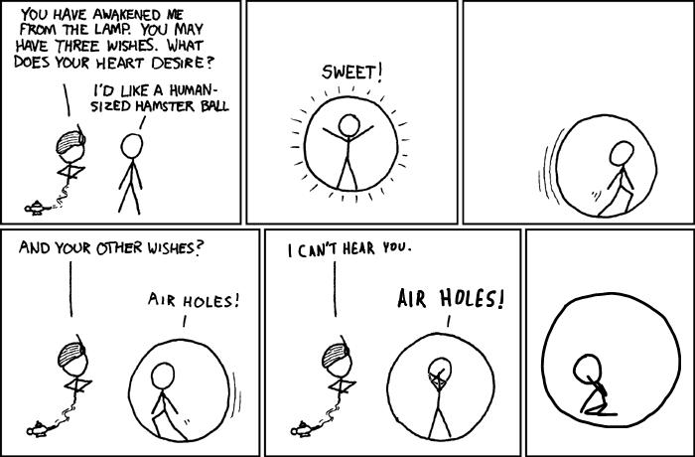

*Be very careful when describing what you want*

*How do you know it’s complete? Ask yourself - are there an gaps or ambiguities? Could I build this right now or do I need more information?*

*Example Feature*

*Title: View friends online*

*I want to see which of my friends are online so I can invite them to play a game with me.*

*Conditions of satisfaction*

* *I can join a game lobby.*
* *I can see my friends who are currently online in the lobby.*
* *I can invite a friend to play.*
* *I can receive an invitation to play from a friend.*
* *I can decline an invitation to play.*

1. Complete this whole section by describing each level (puzzles may vary by level)
2. You also need to teach the reader in the Victory Conditions subsection, what must be done to win, when the player loses and under which conditions this happens. In other words, this section explains the goals of the game.